- Develop an 8-bit Microprocessor program to perform 8-bit multiplication and division (A = 14H, B = 06H) and 16-bit multiplication and division (X = 1357H, Y = 0025H) using repeated addition and repeated subtraction. Store the product, quotient and remainder separately and compare the number of loop iterations in each case. Repeat for A = F2H, B = 0AH, X = 9A23H, Y = 0011H.
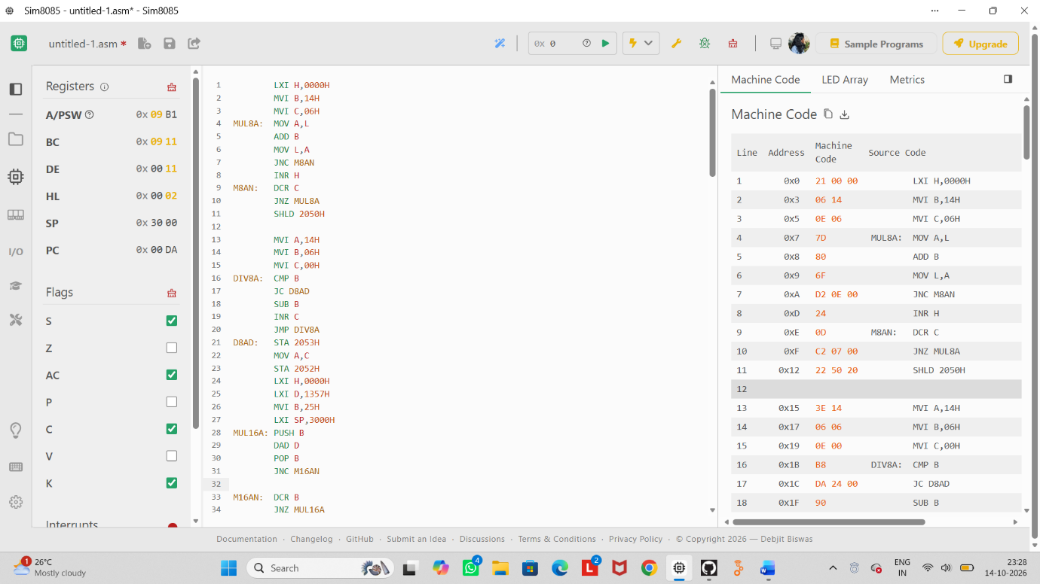
FULL CODE
;====================================================
; 8085 MULTIPLICATION AND DIVISION
; Repeated Addition and Repeated Subtraction
SET 1:
; A = 14H, B = 06H
; X = 1357H, Y = 0025H
SET 2:
; A = F2H, B = 0AH
; X = 9A23H, Y = 0011H
Multiplication: Repeated Addition
; Division: Repeated Subtraction
;====================================================

;====================================================
; SET 1: 8-BIT MULTIPLICATION
; 14H * 06H = 0078H
; Result: 2050H-2051H (LSB-MSB)
;====================================================
LXI H,0000H
MVI B,14H
MVI C,06H
MUL8A: MOV A,L
ADD B
MOV L,A
JNC M8AN
INR H
M8AN: DCR C
JNZ MUL8A
SHLD 2050H
;====================================================
; SET 1: 8-BIT DIVISION
; 14H / 06H = Q=03H, R=02H
;====================================================
MVI A,14H
MVI B,06H
MVI C,00H
DIV8A: CMP B
JC D8AD
SUB B
INR C
JMP DIV8A
D8AD: STA 2053H
MOV A,C
STA 2052H
;====================================================
; SET 1: 16-BIT MULTIPLICATION
; 1357H * 0025H = 0002E4B3H
; Result: 2054H-2057H (LSB to MSB)
;====================================================
LXI H,0000H
LXI D,1357H
MVI B,25H
LXI SP,3000H
MUL16A: PUSH B
DAD D
POP B
JNC M16AN
; Carry into upper word required
M16AN: DCR B
JNZ MUL16A
SHLD 2054H
;====================================================
; SET 1: 16-BIT DIVISION
; 1357H / 0025H = Q=0082H, R=0011H
;====================================================
LXI H,1357H
LXI D,0025H
LXI B,0000H
DIV16A: MOV A,H
CMP D
JC D16AD
JNZ SUB16A
MOV A,L
CMP E
JC D16AD
SUB16A: MOV A,L
SUB E
MOV L,A
MOV A,H
SBB D
MOV H,A
INX B
JMP DIV16A
D16AD: MOV A,C
STA 2058H
MOV A,B
STA 2059H
SHLD 205AH
;====================================================
; SET 2: 8-BIT MULTIPLICATION
; F2H * 0AH = 0964H
; Result: 2060H-2061H
;====================================================
LXI H,0000H
MVI B,F2H
MVI C,0AH
MUL8B: MOV A,L
ADD B
MOV L,A
JNC M8BN
INR H
M8BN: DCR C
JNZ MUL8B
SHLD 2060H
;====================================================
; SET 2: 8-BIT DIVISION
; F2H / 0AH = Q=18H, R=02H
;====================================================
MVI A,F2H
MVI B,0AH
MVI C,00H
DIV8B: CMP B
JC D8BD
SUB B
INR C
JMP DIV8B
D8BD: STA 2063H
MOV A,C
STA 2062H
;====================================================
; SET 2: 16-BIT MULTIPLICATION
; 9A23H * 0011H = 000A4263H
; Result: 2064H-2067H
;====================================================
LXI H,0000H
LXI D,9A23H
MVI B,11H
MUL16B: PUSH B
DAD D
POP B
JNC M16BN
; Carry into upper word required
M16BN: DCR B
JNZ MUL16B SHLD 2064H

;====================================================
; SET 2: 16-BIT DIVISION
; 9A23H / 0011H = Q=0927H, R=000CH
;====================================================

LXI H,9A23H
LXI D,0011H
LXI B,0000H

DIV16B: MOV A,H
CMP D
JC D16BD
JNZ SUB16B
MOV A,L
CMP E
JC D16BD

SUB16B: MOV A,L
SUB E
MOV L,A
MOV A,H
SBB D
MOV H,A
INX B
JMP DIV16B
D16BD: MOV A,C
STA 2068H
MOV A,B
STA 2069H
SHLD 206AH
HLT

